



Contact:

**Angelo Virgilio**

[Angelo.virgilio@ecin.ca](mailto:Angelo.virgilio@ecin.ca)

Mobile: 416.605.1296

Ixchariot – User MANUAL

Bell Canada; ATL Lab

|  |
| --- |
| **Revisions** |

| Version | Primary Author(s) | Description of Version | Date Completed |
| --- | --- | --- | --- |
| 0.1 | Arijit Saha | First Draft version |  |

|  |
| --- |
| **Review & Approval** |

Requirements Document Approval History

| Approving Party | Version Approved | Signature | Date |
| --- | --- | --- | --- |
| **Bell Canada:**  **Intissar Harrabi** |  |  |  |
|  |  |  |  |

Requirements Document Review History

| Reviewer | Version Reviewed | Signature | Date |
| --- | --- | --- | --- |
| **Angelo Virgilio** |  |  |  |
|  |  |  |  |
|  |  |  |  |

Contents

1. Configuring Common Parameters 3

2. Configuring Test Parameters 7

3. Configuring Result Arguments 12

4. Creating Test Case 14

## Configuring Common Parameters

* + - 1. From the left panel, click on the **userconfig.txt**.

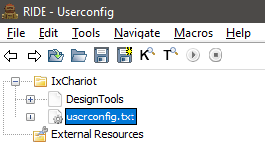

* + - 1. On the right, it will open the edit tab of the userconfig.txt.

Here the user will find the common parameters and the values for each of them.

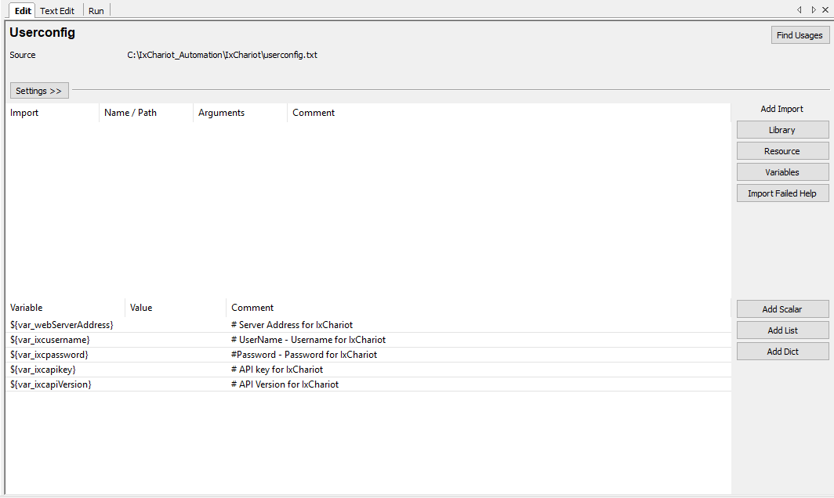

* + - 1. The user has to provide the values for username, password, API key, API version and the IP address for IxChariot web version.

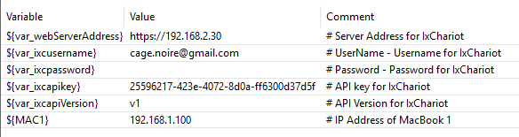

* + - 1. Double click on the variable name, pop up will appear.

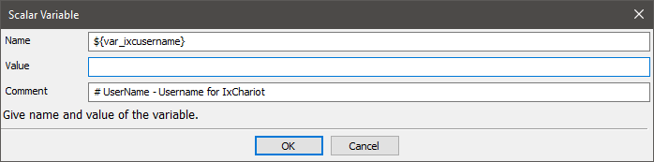

* + - 1. Here the user can enter the value for each variable. Do not change the variable name. 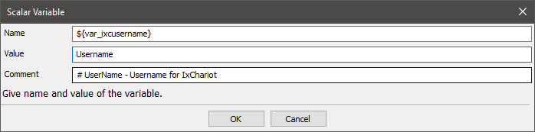
      2. The user can give the value of the other variables repeating step 4 and 5.
      3. The user can find the values of username, password and API Key in the settings of IxChariot WebAPI.
      4. To find the above values, follow the steps below.
      5. After logging into the user account, on the top right side, the user will find the **settings** button.

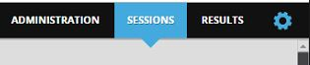

* + - 1. On clicking of that, a drop down will come. Choose **My Account** from the dropdown.

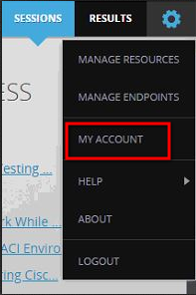

* + - 1. From the My Account page, the user can find the values for the username, password, and API key (Click on the Show button to see).

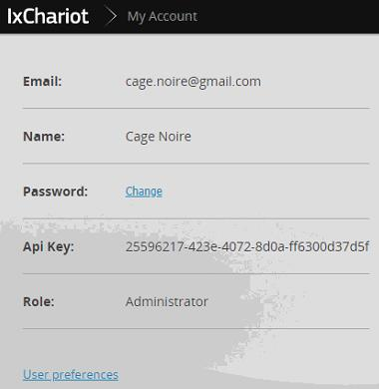

## **Configuring Test Parameters**

1. Now on the left panel, click on the plus sign next to **DesignTools** to expand.

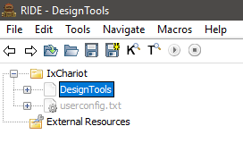

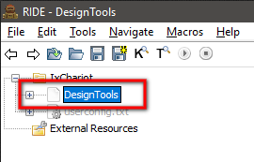

1. Under the DesignTools, the user will find **Create** **Flows**.
2. Click on the **Create** **Flows**.

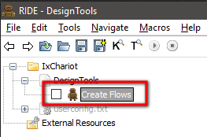

1. It will open the edit tab.

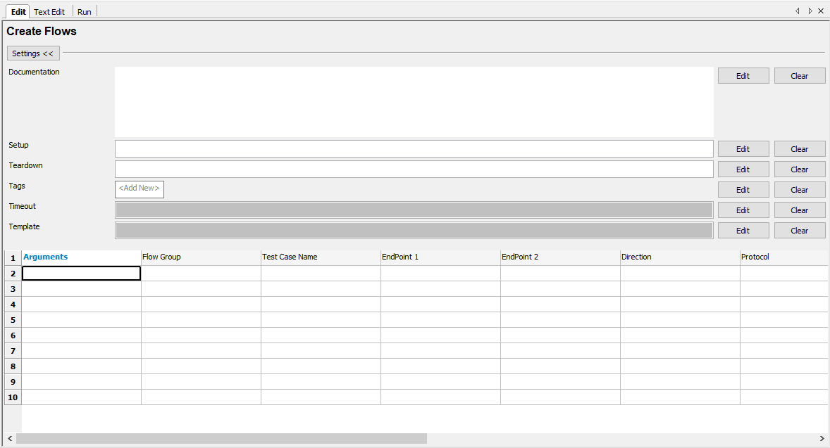

1. Click on the **Edit** button next to the **Teardown** text box.

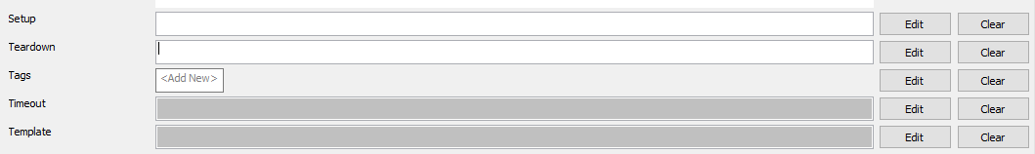

1. A pop up will come up.

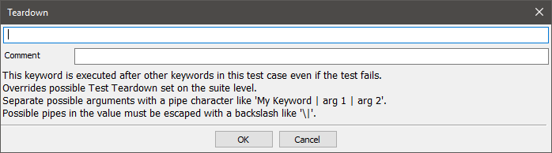

1. From the popup, enter **Refresh** in the first textbox and click OK button.

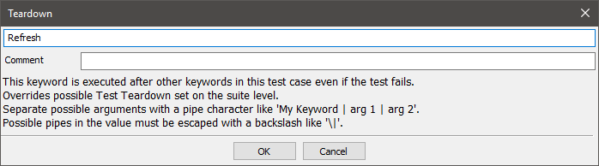

1. Now the user has to configure the parameters. In the first cell of the row, the user has to enter the command name **CreateTestCase**.

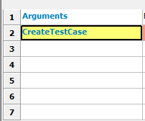

1. The parameters that the user has to configure for creating the test case files are mentioned below.

|  |  |
| --- | --- |
| Parameters | Comments |
| Flow Group | User can enter a value for group name. Example: MAC |
| Test case name | It can be given as the user wants to name the test case.  Example: Bell_MAC1 |
| End Point 1 | This will be the name of the variable name mentioned in userconfig.txt file for the endpoint IP. T  Example: If user has used MAC1 for 192.168.2.100 in userconfig.txt file, then enter MAC1 for EndPoint1. |
| End Point 2 | Similar to End Point 1, this value must match the value that is given in the userconfig.txt.  Note: It must not be the same as the value of the End Point 1. |
| Direction | Must be either DS / US. |
| Protocol | Must be either TCP / UDP. |
| Script | Throughput Tests   * TCP High Performance * TCP Low Performance * TCP Small Packets Performance * TCP Baseline Performance * TCP Small Packets Performance * UDP Low Performance * UDP Baseline Performance * UDP High Performance |
| Duration (seconds) | The user can enter an integer value. |
| Create | Must be either Yes / No.  Default value is Yes if left blank. |
| Number of Users | The maximum number of users can be 10 as per the current license at Bell. |

1. Here is a sample after the user enters the values for the parameters (given in the above table).

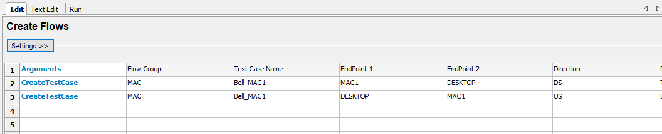

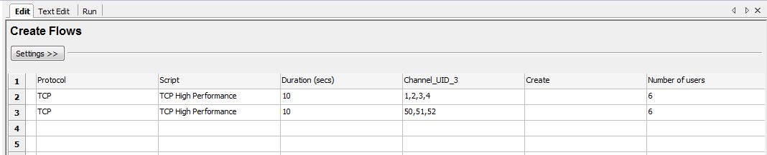

1. The user can repeat the steps 8 & 9 for creating multiple test cases.

## Configuring Result Arguments

The section aims to customize the result files name, location and the background color.

The above command needs to be inserted in the arguments section, following the steps:

1. Click on project name.

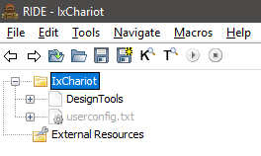

1. Click on **Run** tab.

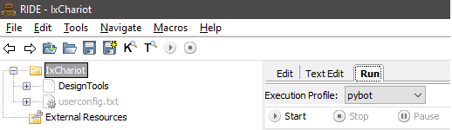

1. Copy the command **“-d ..\\IxChariot_Results --timestamp --reportbackground white:white:white”** and paste it in arguments text area as shown.

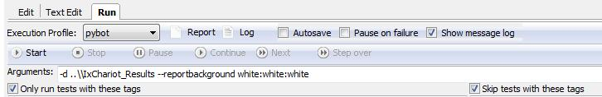

1. Select Execution Profile as **pybot** (if not already selected).

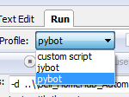

1. Click to checkbox to mark as selected for Show message log (if not already selected).



## Creating Test Case

To start the execution, click on the checkbox to the left of “**Create Flows**”.

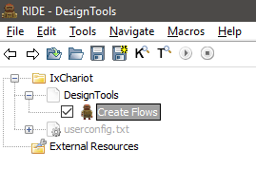

Click on the **Run** tab.

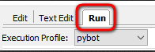

Click on the **Start** button to start the execution.

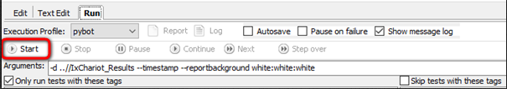

On clicking of the button, the execution will start.

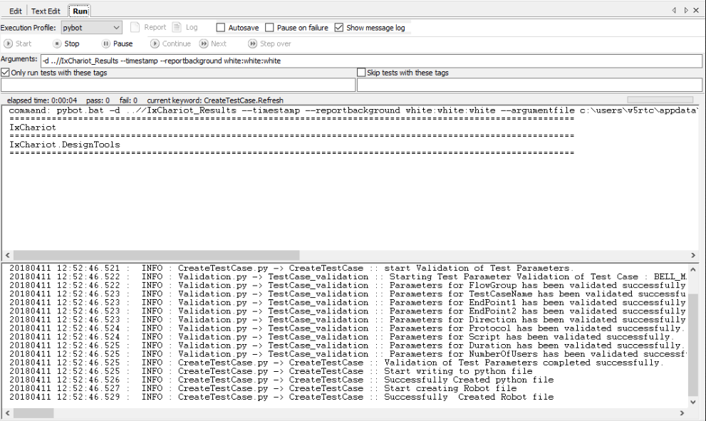

On successful execution, RIDE will close and automatically reopen with the Flow group test suites appearing on the left under the Design Tools.

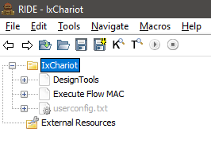

It will show all the test case listed under the Flow Group name during creation.

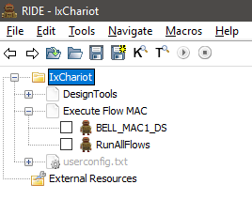

Once the test case is executed successfully, then click on the **Log** button to view the log of the executed test case and click on the **Report** button to view the report of the executed test case.

Screen Clipping

RIDE will not close if there is a validation error of the test input parameters and it will show the appropriate error message in the console.

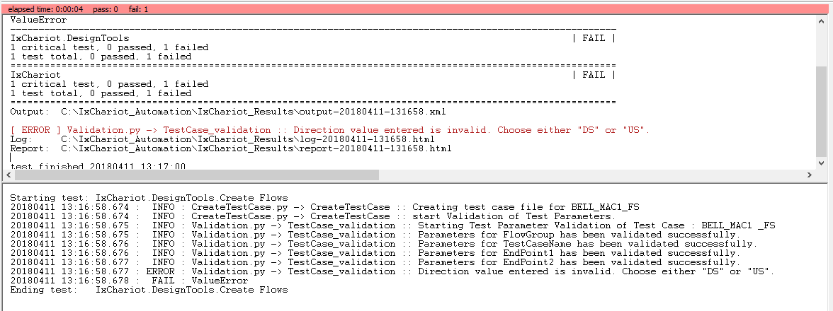

After checking and solving the cause of error from the log, the user can re-run the test case.